Rashmi Sarwal (Main code), Abhijnan Kar (Supporting)

RAWS-2021

**EXPERIMENT- 4**

**Detecting a Pulsar in Ooty Radio Telescope Voltage Data**

* **AIM :-**

1. *Visualize the voltage time-series*
2. *Plot and characterize the distribution of the telescope voltage data*
3. *Visualize the power time-series*
4. *Plot and characterize the distribution of the power values*
5. *Power Spectral Density: obtain the distribution of power in various frequency bins*
6. *Dynamic spectrum: visualize the change in power spectral density as a function of time*
7. *Use de-dispersion and phase folding to recover the pulsar’s integrated pulse profile.*

* **DATASET:-**

*The dataset used is “*[*ch00_B0833-45_20150612_191438_011_1.txt*](http://repository.iucaa.in:8080/jspui/bitstream/11007/4565/1/ch00_B0833-45_20150612_191438_011_1.txt)*”.*

**Description of Data:**

* *The file has two columns of integer values, separated by a space.*
* *Voltage time series from the Ooty Radio Telescope (ORT) — North and South apertures*
* *As raw voltages, the data are in arbitrary units*
* *The observation frequency is 326.5±8.25 MHz which has been down-converted to the base band. The voltages hence occupy the 0−16.5 MHz band.*
* *The data is sampled at the Nyquist rate, i.e., two real valued voltage measurements in a period corresponding to the maximum variability time-scale (maximum frequency). The time-resolution is,*

*δt=($\frac{1}{2}\frac{1}{116.5MHz}$)seconds*

* *The length of the data is about 1 second.*
* **DATA-ANALYSIS TOOLS:-** *Python Programming (libraries like pandas, numpy, matplotlib, scipy, seaborn), google colab platform*.
* **THEORY :-**

*The data are voltage time-series containing signal proportional to electric field component of the incident EM radiation received by radio telescope, including that of astronomical origin.*

*The observed Electric field could be varying in MHz or GHz frequencies but for processing on computers they are converted down to lower frequencies.*

*Also, as we know any function that is varying in time can be reconstructed using sines and cosines. We can get the constituent frequencies and its amplitude in frequency space using Fourier transform. We are measuring electric field which changes in time. We view this as superposition of waves of different frequencies. And essentially if we take Fourier transform of this Electric field with time we will get individual frequencies that go into constructing this electric field.*

* **FORMULE :-**
* *Gaussian Distribution:-*

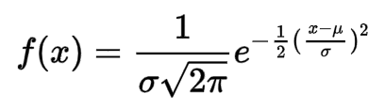

*where,*

***x*** *= Voltage Data.*

***σ****= Standard Deviation*

***μ*** *= Mean*

* *Dispersion due to the interstellar medium could be the source of the frequency-dependent delay in the period signal. The delay of a signal at frequency ν relative to an infinite-frequency signal emitted at the same time from the source is*

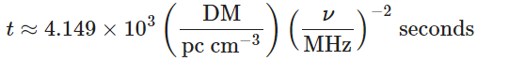

*where, DM is the dispersion measure along the line of sight.*

* *Expected DM for a measured time delay Δt between two frequencies ν1,ν2,*

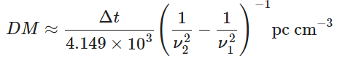

* **OBSERVATIONS :-**

1. *The voltage time-series for complete dataset (north and south antenna).*

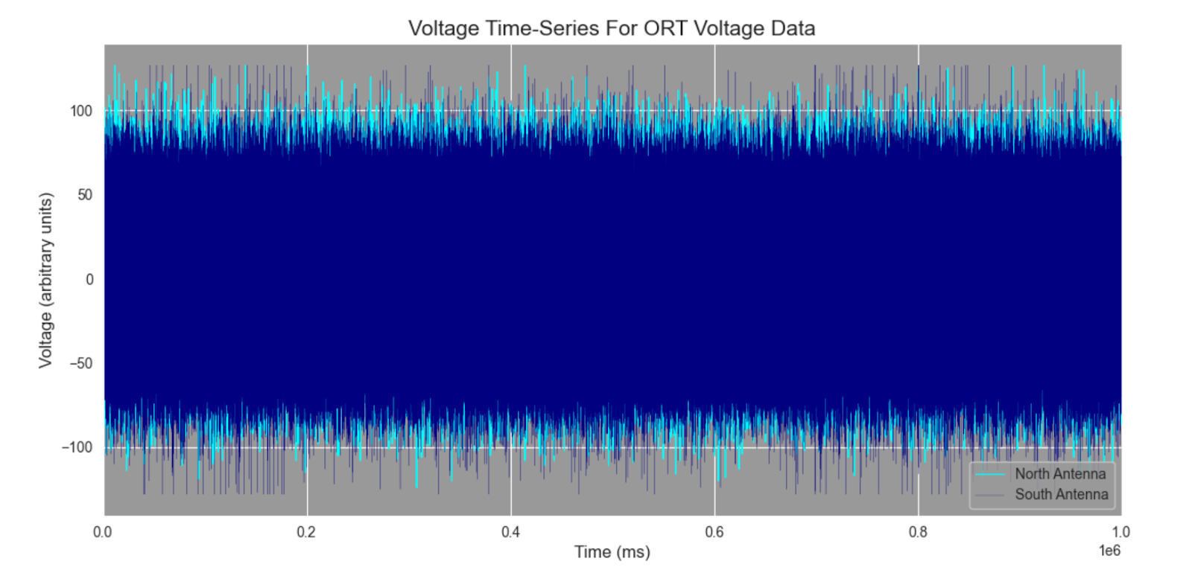

* + The voltage time-series for some (9000 from top) data (north and south antenna).

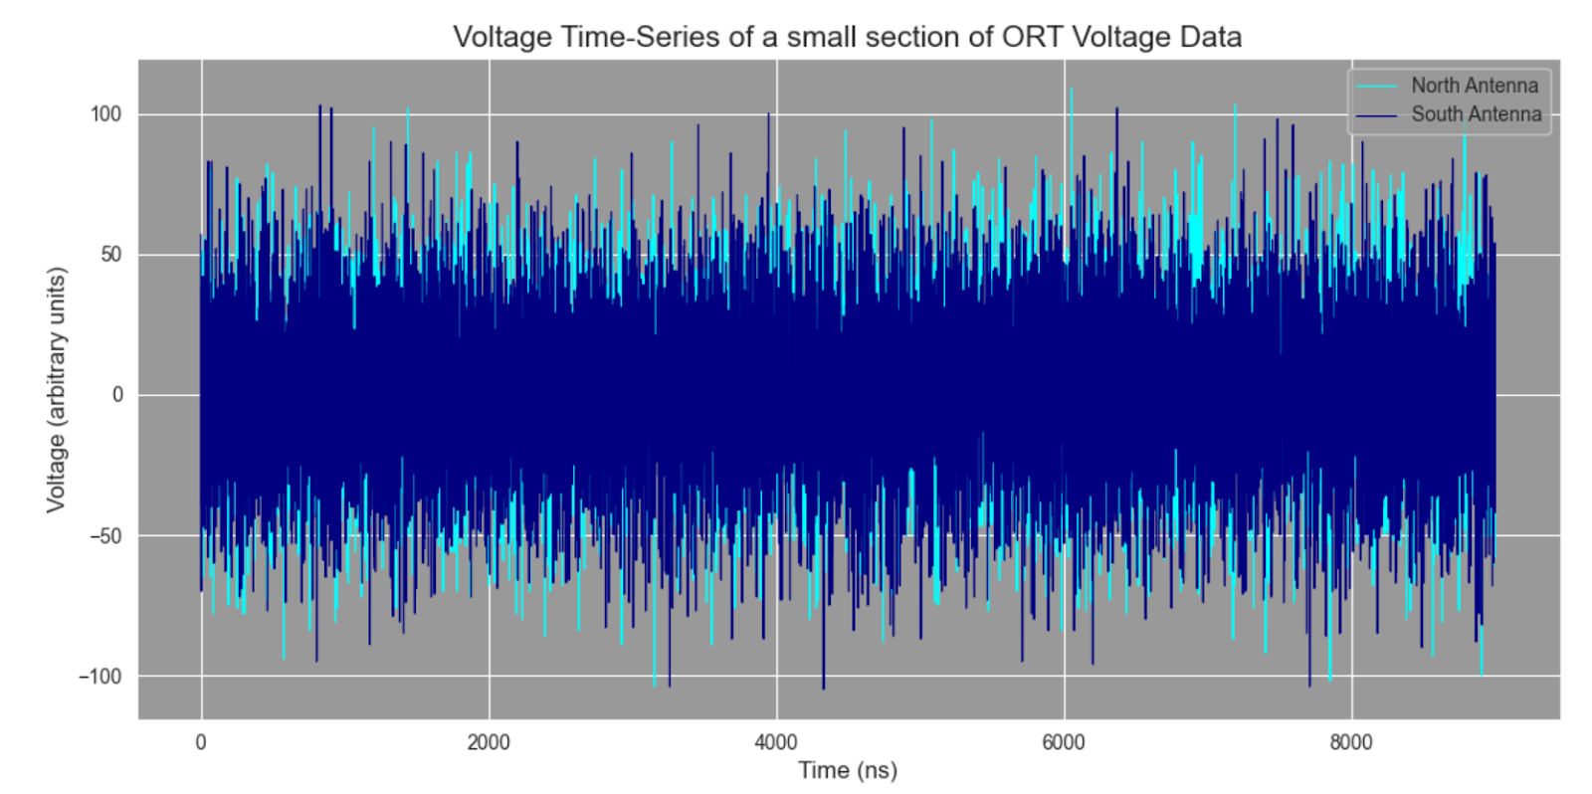

#### *Plot the voltage histograms for the two antennas.*

* *Obtain distribution parameters using numpy methods for mean and standard deviation*
* *Try plotting the probability density function from the measured distribution parameters*
  1. ***For North Antenna***

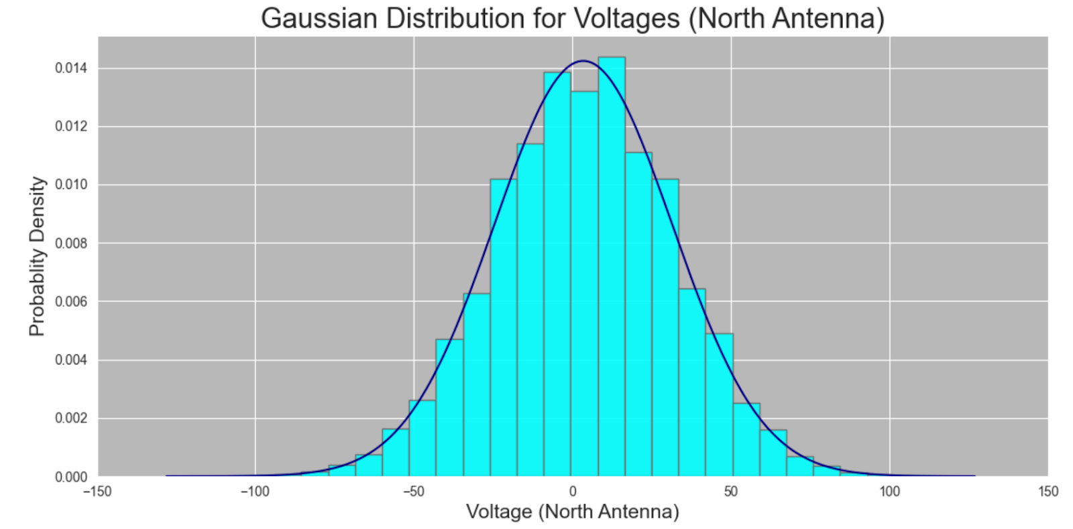

*We calculated mean and standard deviation using numpy.mean() and numpy.std() method respectively.*

*Mean (North Antenna)=3.485*

*Standard Deviation(North Antenna)=28.03*

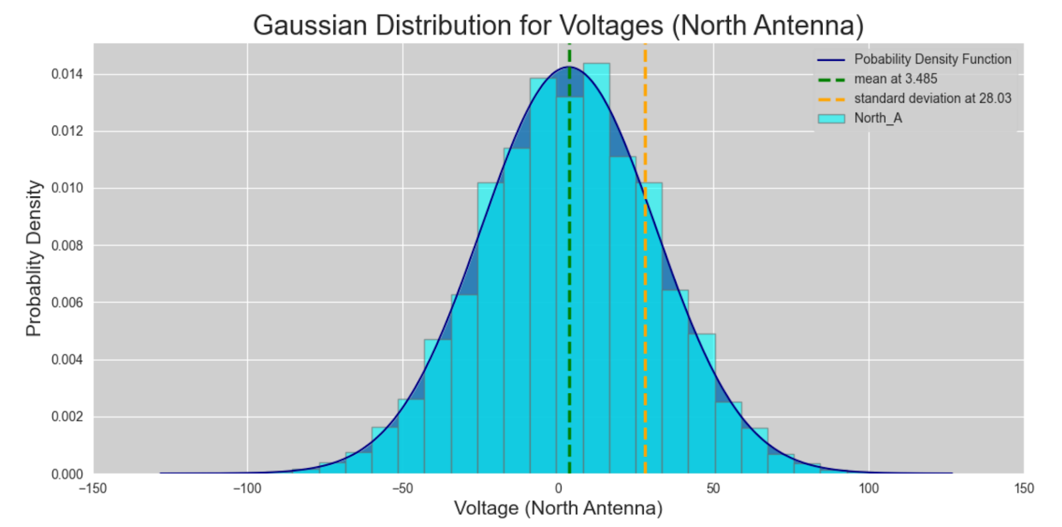

* 1. ***For South Antenna***

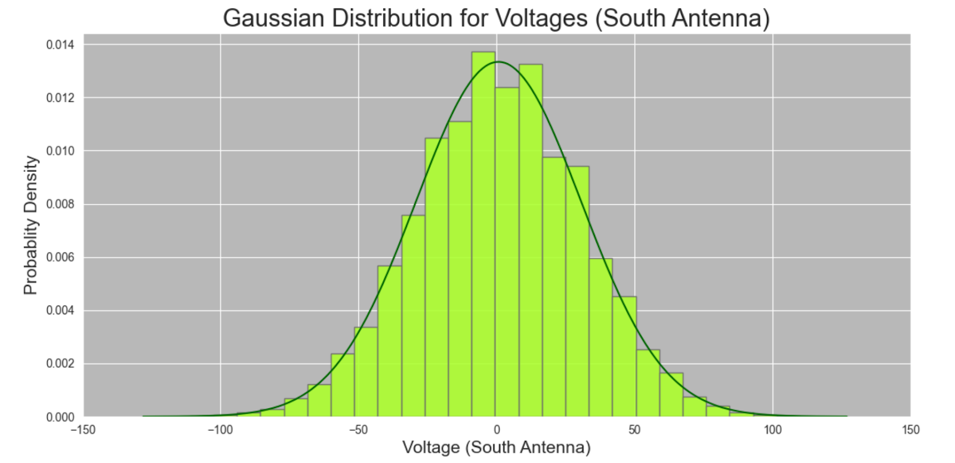

*We calculated mean and standard deviation using numpy.mean() and numpy.std() method respectively.*

*Mean (South Antenna)=0.775*

*Standard Deviation(South Antenna)=29.92*

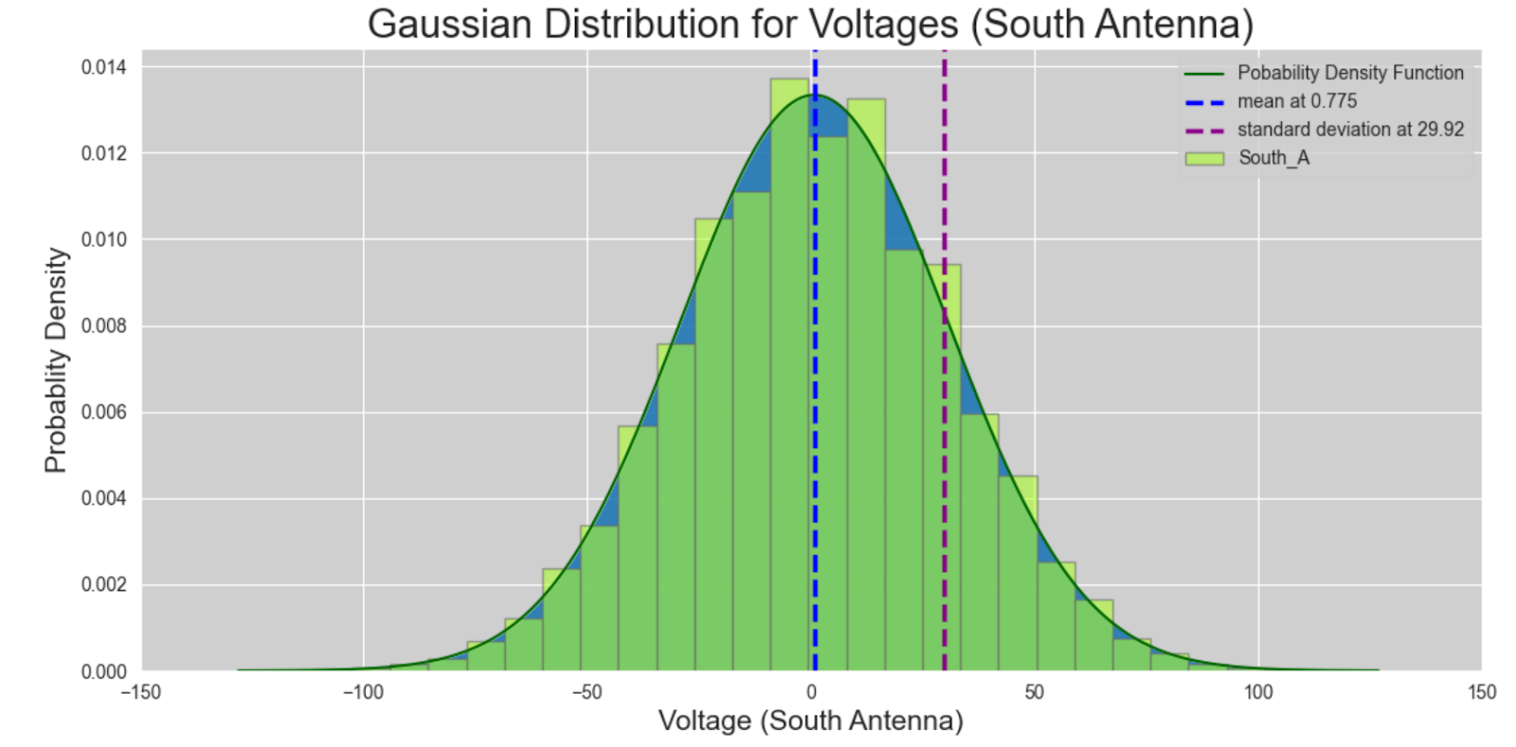

*We Plotted Probability density function for both antennas using gaussian (normal) distribution equation as we expected this voltage data will follow gaussian distribution which we can see through histogram for north and south antenna respectively. Below is histogram for both antenna.*

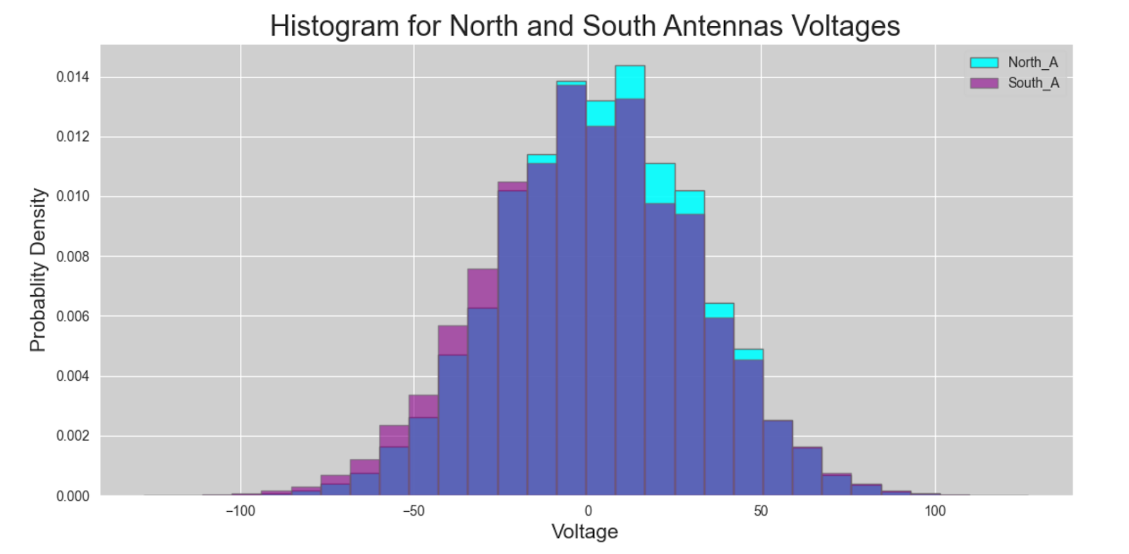

#### *Plot the power from North and South antennas as a function of time.*

* + *The power time-series for some (9000 from top) data (north and south antenna).*

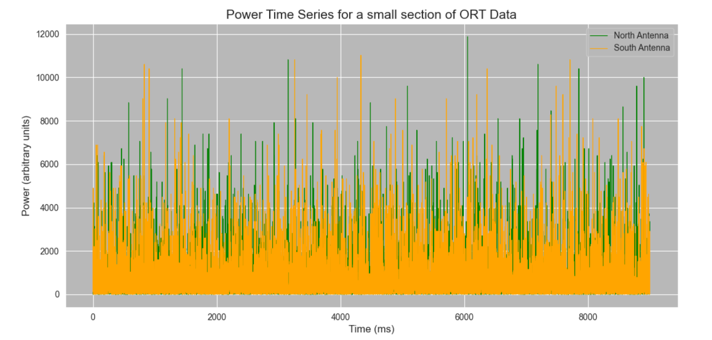

#### *Plot the power histograms for the two antennas.*

* *Plot appropriate probability density function and find its spread.*
  1. ***For North Antenna***

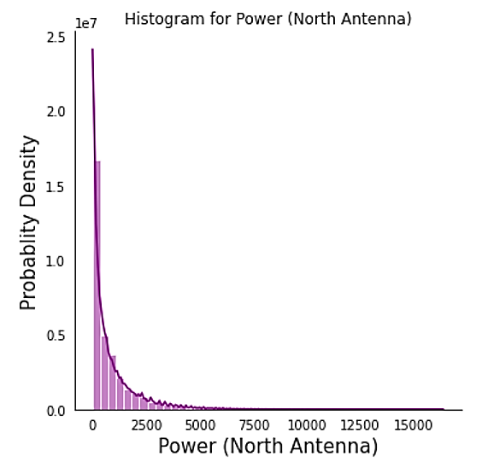

* 1. ***For South Antenna***

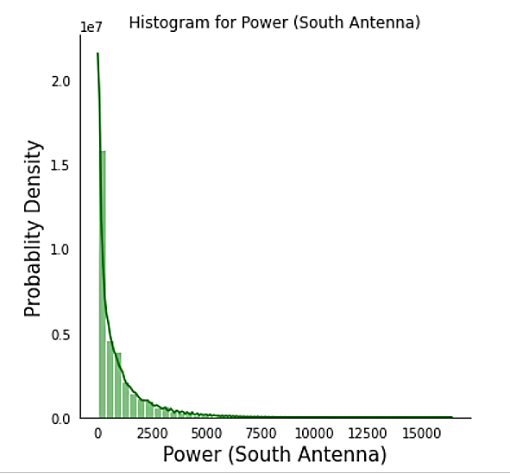

*We have calculated power partwise and we combined those part in one dataset and plotted histogram as power is square of voltage data and voltage data show gaussian distribution so we expect exponential decay curve for power data power density curve which we plotted using seaborn for both antennas.*

#### *Convert voltage time-series to dynamic spectrum (spectral time-series*)

**Frequency and time binning parameters**

Chosen number of frequency bins = 512

Time-resolution of voltage sampling = 30.30 nanosecond

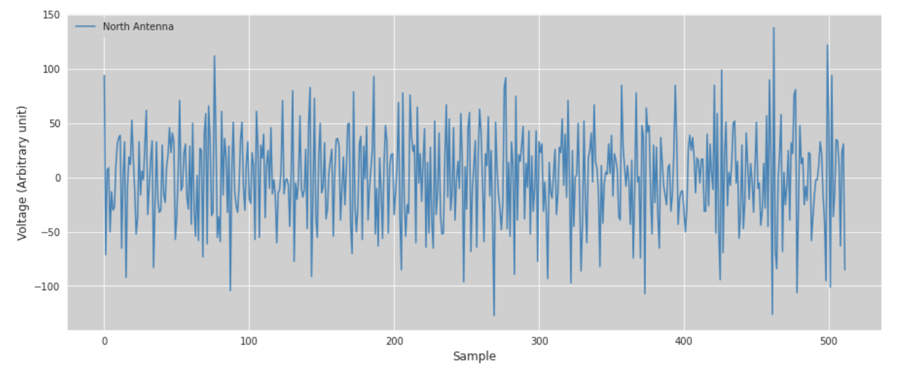

**Voltage Time-Series for Sample-1 which contain 512 points**

* ***Frequency and time binning parameters***

*Chosen number of frequency bins = 512*

*Time-resolution of voltage sampling = 30.30 nanosecond*

*----------FFT length-----------*

*Number of voltage samples to obtain FFT =  512*

*Number of spectra obtained through the 512-point FFT = 256*

*Time-resolution of the spectral series = 15.52 microsecond*

*----------Time rebinning-----------*

*Number of spectra to add = 60*

*Time-resolution of the co-added time series = 930.909090909091 micro-second*

*Binned time-series has resolution <= 1 ms*

1. *Single Power Spectra for 512 voltage points*

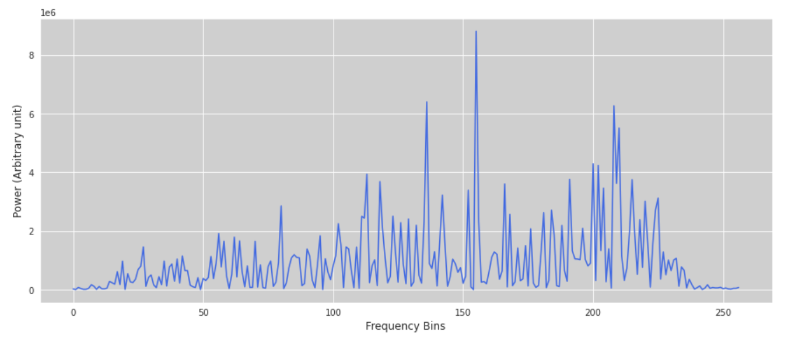

1. *Collection of Power Spectra combined to series of improved power spectra.*

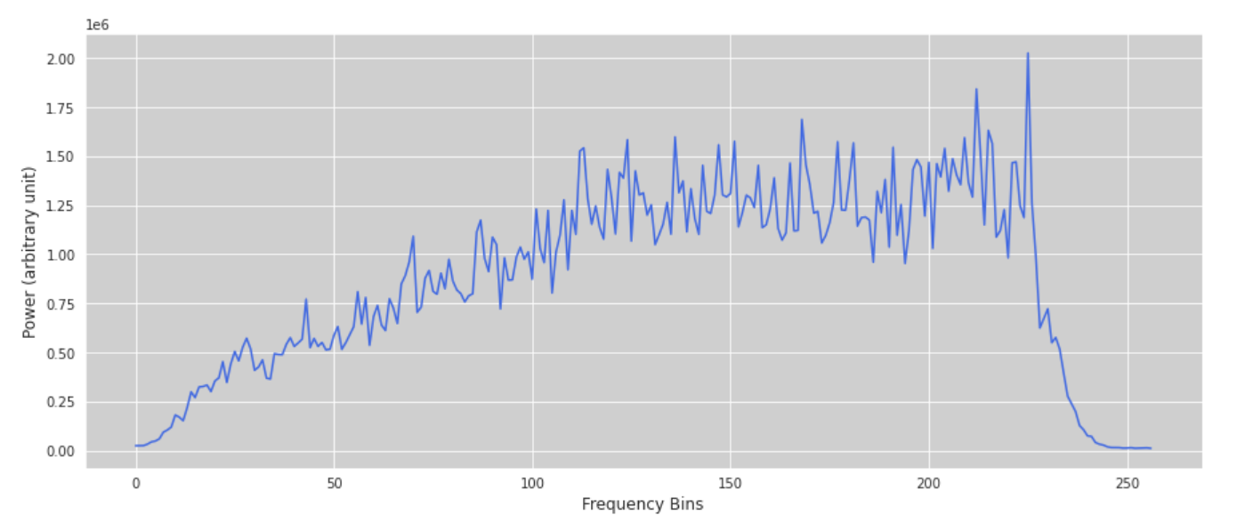

1. *Average Power Spectra*

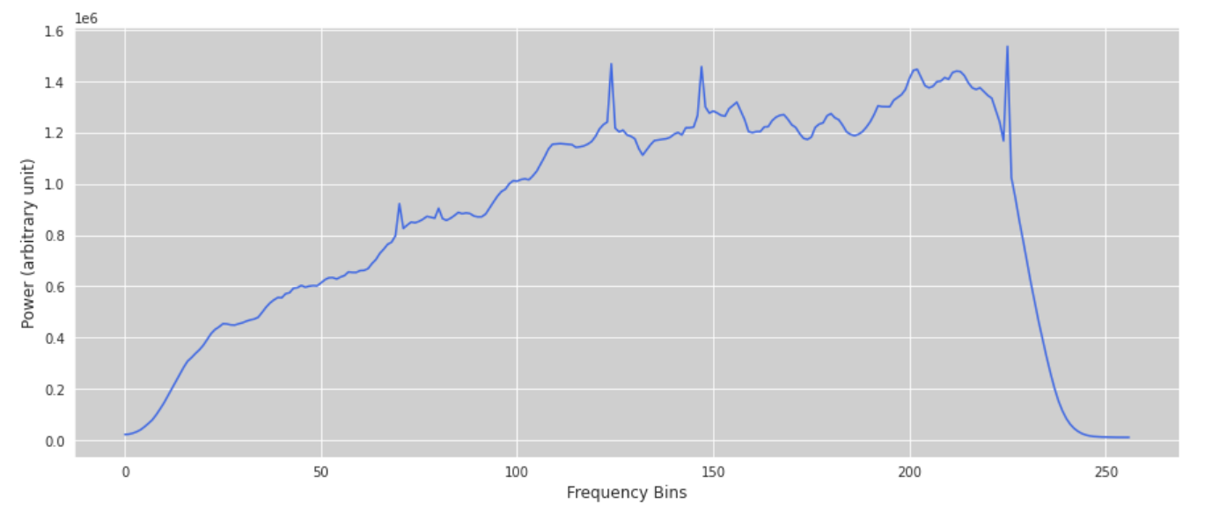

1. *The Dynamic Spectrum*

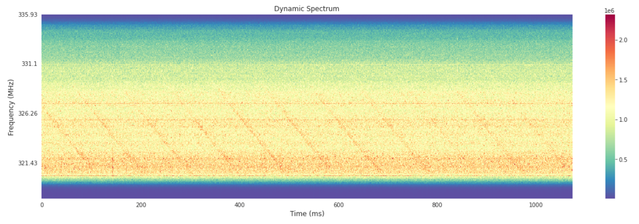

1. *For De-Dispersion (De-Disperse Spectrum)*

*DM for a measured time delay Δt=100 ns between two frequencies v1 = 322.25, v2 = 328.58 MHz is* ***65.5923807249108*** *pc cm-3*

*The number of bins for time shift of Δt will be equal to the* ***delay of a signal at frequency ν*** *divided by* ***the length of time per bin****, where Length of time per bin is the time resolution of the spectral series.*

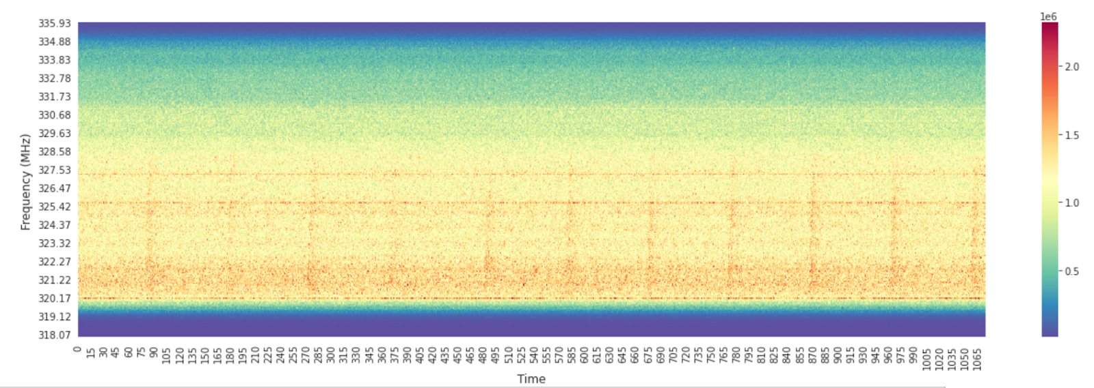

1. *Pulse Profile:*

*We can clearly see the periodic pulses here, signature of pulsars.*

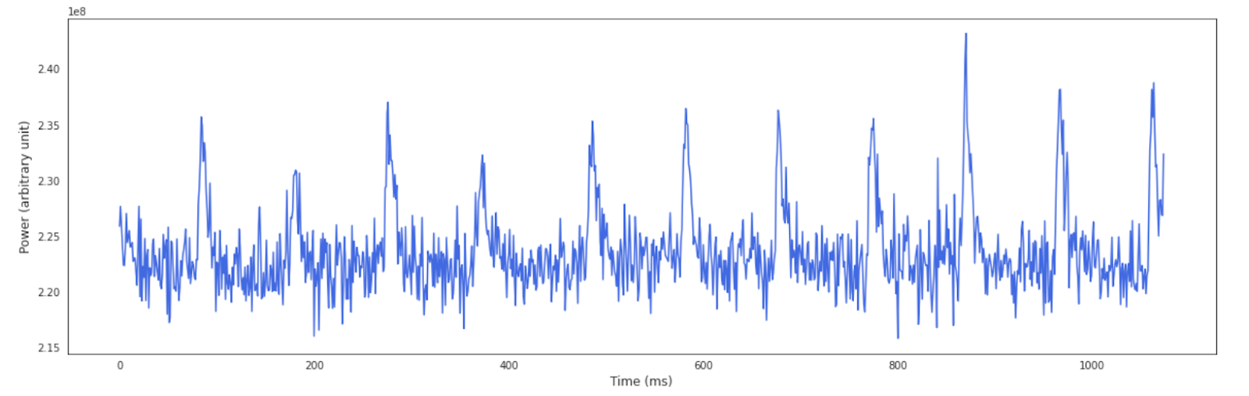

* **COLAB LINK:-**

1. [*https://colab.research.google.com/drive/1d7ZKQcyvL4u6Ag7I_Rw8PwHQ-ms3WlZG?usp=sharing*](https://colab.research.google.com/drive/1d7ZKQcyvL4u6Ag7I_Rw8PwHQ-ms3WlZG?usp=sharing)
2. [*https://colab.research.google.com/drive/1Buc4BadNw66RQprGOYLnSVbHZG-tJYBo?usp=sharing*](https://colab.research.google.com/drive/1Buc4BadNw66RQprGOYLnSVbHZG-tJYBo?usp=sharing)

* **REFERENCES:-**

1. [*https://colab.research.google.com/drive/11K9rmTaLpiOl_XNy7iCs525Dy4gDYnIw?usp=sharing#scrollTo=Mrf6QpeWvUb_*](https://colab.research.google.com/drive/11K9rmTaLpiOl_XNy7iCs525Dy4gDYnIw?usp=sharing#scrollTo=Mrf6QpeWvUb_)
2. [*http://hdl.handle.net/11007/4565*](http://hdl.handle.net/11007/4565)